08. Algorithm

- Greedy Algorithm

Greedy algorithms work in phases. In each phase, it makes the locally optimal choice with the hope of finding a global optimum. In many problems, greedy algorithm does not in general produce optimal solutions. It is usually used to provide approximately optimal solution, rather than using the more complicated algorithms required to generate an exact answer. The Dijkstra's, Prim's, and Kruskal's algorithms are all greedy algorithm.

Job Scheduling Problem

Given n jobs j₁, j₂, …, j_{n}, with the known running time t₁, t₂, …, t_{n}, respectively. We have a single processor under a non-preemptive scheduling environment. What is the best way to schedule these jobs in order to minimize the average completion time? The solution is to run the shortest job first.

For example, there are four jobs j₁, j₂, …, j_{n}, with the known running time 15, 8, 3, 10. If we run the jobs in the order of j₁, j₂, j₃, j₄, the average completion time is (15 + 23 + 26 + 36) / 4 = 25. If we run the shortest job first, which is in the order of j₃, j₂, j₄, j₁, then average completion time is (3 + 11 + 21 + 36) / 4 = 17.75.

Huffman Codes

In a Huffman tree, all the characters are placed only at the leaves. The representation of each character can be found by starting at the root and recording the path, using a 0 to indicate the left branch and a 1 to indicate the right branch. Any sequence of bits can always be decoded unambiguously.

The following shows how to build a Huffman tree.
- Create a leaf node for each character and build a heap for all the nodes.
- Perform two deleteMin operations to get two nodes with the minimum frequency from the heap.
- Create a new node and set its frequency to the sum of the two nodes' frequencies. Make the first node as its left child and the other node as its right child. Add this node to the heap.
- Repeat steps 2 and 3 until the heap contains only one node.

Suppose that we have a list of characters and their frequencies as below: a (5), b (9), c (12), d (13), e (16), f (45). The following shows the Huffman tree built from them.

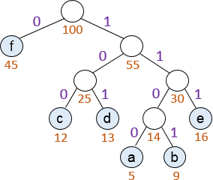

So we have the Huffman codes for the characters are f: 0, c: 100, d: 101, a: 1100, b: 1101, e: 111.

Bin Packing Problem

Given n items of size s₁, s₂, …, s_{n}, where 0 < s_{i} ≤ 1 for 1 ≤ i ≤ n. The bin packing problem is to pack these items in the fewest number of bins, given that each bin has unit capacity.

In on-line bin packing, each item must be placed in a bin before the next item can be processed. An on-line algorithm cannot always give an optimal solution.

In off-line bin packing, an answer can be produced after all the items are input. A greedy algorithm to solve this problem is called first fit decreasing. We sort the items in decreasing order, and place them one by one. To locate an item, we scan the bins in order, and place the item in the first bin that is large enough to hold it. A new bin is created only when there is no bin that is large enough to hold the item.

The following shows how to pack seven items with sizes of 0.8, 0.7, 0.5, 0.4, 0.3, 0.2, 0.1.

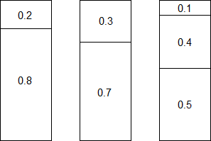

- Divide and Conquer

Divide and conquer algorithms consist of two parts. In the divide part, a problem is divided into two or more smaller sub-problems of the same or related type which are solved recursively. In the conquer part, the solution to the original problem is formed from the solutions to the sub-problems. The examples of divide and conquer algorithms include the merge sort and quick sort.

Traditionally, routines in which the text contains at least two recursive calls are called divide and conquer algorithms, while routines whose text contains only one recursive call are not. We generally insist that the sub-problems be disjoint. For example, efficient exponentiation is not a divide and conquer algorithm.

long pow(long x, int n)
{
if (n == 0) return 1;
if (n == 1) return x;

if (n % 2 == 0)
return pow(x * x, n / 2);
else
return pow(x * x, n / 2) * x;
}

The following theorem can be used to determine the running time of most divide and conquer algorithms.

Theorem: The solution to the equation T(n) = aT(n/b) + Θ(n^{k}), where a ≥ 1 and b > 1, is

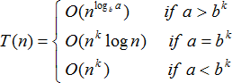

Integer Multiplication

To multiply two n-digit numbers x and y, let x = x₁⋅10^{k} + x₂ and y = y₁⋅10^{k} + y₂, then we have:

For example, if x=61438521, y=94736407, we have x₁=6143, x₂=8521, y₁=9473, y₂=6407. Using this formula, we need 4 multiplications and 3 additions, so the time complexity is:

However, if we use the following formula:

We have 3 multiplications (x₁y₁ and x₂y₂ have already been performed), so the time complexity is:

Matrix Multiplication

Let A, B be two n × n matrices. To calculate C = A⋅B, the traditional method needs O(n³) time. We can divide the matrix into four n/2 × n/2 sub-matrices.

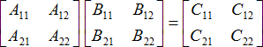

If we use the traditional multiplication:

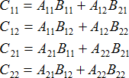

Then the time complexity is the same as the traditional method.

Strassen’s algorithm is a divide and conquer algorithm. It uses the following formulas:

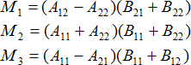

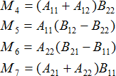

Then the matrix C is calculated by:

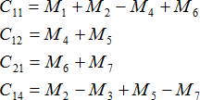

The time complexity is:

- Dynamic Programming

Dynamic programming breaks a complex problem into smaller sub-problems, solves each sub-problem and stores its solution. The next time the same sub-problem occurs, we use the saved solution instead of re-computing it. Usually, dynamic programming uses non-recursive algorithms to solve problems.

An example is the Fibonacci numbers 1, 1, 2, 3, 5, 8, 13, 21, 34, 55, …. They can be defined as below.
- f₁ = f₂ = 1.
- f_{n} = f_{n-1} + f_{n-2}, where n ≥ 3.

The following shows a tiling with squares whose side lengths are successive Fibonacci numbers.

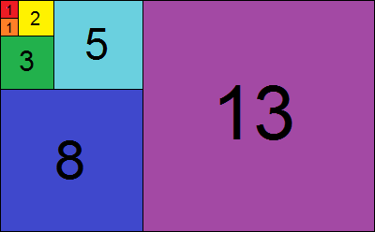

The following shows a recursive program to compute the Fibonacci numbers. This program is very inefficient because fib(n – 2) is computed twice, one of which is computed in the recursion of fib(n – 1) .

int fib(int n)
{
if (n < 3)
return 1;
else
return fib(n – 1) + fib(n – 2);
}

The following shows a non-recursive program to compute the Fibonacci numbers.

int fib2(int n)
{
if (n < 3)
return 1;

int last = 1;
int nextToLast = 1;
int f = 0;

for (int i = 3; i <= n; ++i)
{
f = last + nextToLast;
last = nextToLast;
nextToLast = f;
}

return f;
}

- Randomized Algorithms

During a randomized algorithm, at least once a random number is used to make a decision. The running time of the algorithm depends not only on the input but also on the random numbers. The worse-case running time of a randomized algorithm is almost always the same as the worse-case running time of the non-randomized algorithm. The important difference is that a good randomized algorithm has no bad inputs, but only bad random numbers.

Quicksort is one of the algorithms in which randomness is used. Any deterministic version of this algorithm requires O(n²) time to sort n numbers. However, if the algorithm selects pivot elements uniformly at random, it has a high probability of finishing in O(n log n) time regardless of the characteristics of the input.

Random Number Generator

The standard method to generate random numbers is the linear congruential generator. Numbers x₁, x₂, … are generated by satisfying:
x_{i + 1} = A⋅ x_{i} mod M
Where A and M are large integers (usually primes). For example, A = 48271, M = 2³¹ – 1 = 2147483647. To start the sequence, some value of x₀ must be given, which is known as the seed.

- Backtracking

Backtracking is a refinement of the brute force approach, which systematically searches for a solution to a problem among all available options. Backtracking can be applied only for problems which admit the concept of a "partial candidate solution" and a relatively quick test of whether it can possibly be completed to a valid solution. It abandons a partial candidate as soon it determines that the candidate cannot possibly be completed to a valid solution. Therefore, backtracking is often much faster than brute force enumeration of all complete candidates, since it can eliminate a large number of candidates with a single test.

The following shows the pseudocode of the backtracking algorithm.

bool solve(problem)
{
if (problem is solved)
return true;

for (all available choices)
{
pick up one choice c;
mark choice c;

if (solve(c))
return true;

unmark choice c;
}

return false;
}

Eight Queens Puzzle

The eight queens puzzle is the problem of placing eight queens on an 8×8 chessboard so that no two queens threaten each other. Thus, a solution requires that no two queens share the same row, column, or diagonal. Using backtracking, the partial candidates are arrangements of k queens in the first k rows of the board, all in different rows, columns, and diagonals. Any partial solution that contains two mutually attacking queens can be abandoned.

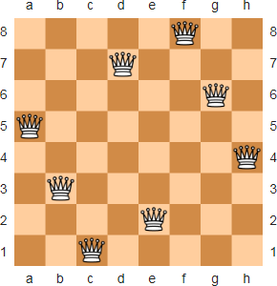

The following shows the code.

bool SolveEightQueen(int a[][], int row)
{
if (row == 8)
{
return true;
}

for (int col = 0; col < 8; col++)
{
if (checkPosition(a, row, col))
{
a[row][col] = 1;

if (SolveEightQueen(a, row + 1))
{
return true;
}

a[row][col] = 0;
}
}

return false;
}

bool checkPosition(int a[][], int row, int col)
{
// check the rows above
for (int i = 0; i < row; i++)
{
if (a[i][col] == 1)
return false;
}

// check upper diagonal on the left side
for (int i = row, j = col; i >= 0 && j >= 0; --i, --j)
{
if (a[i][j] == 1)
return false;
}

// check upper diagonal on the right side
for (int i = row, j = col; i >= 0 && j < 8; --i, ++j)
{
if (a[i][j] == 1)
return false;
}

return true;
}

Sudoku

The Sudoku puzzles can be solved using a backtracking algorithm. It visits the empty cells in some order, filling in digits sequentially, or backtracking when the number is found to be not valid.

Briefly, a program solves a puzzle by placing the digit "1" in the first empty cell and checking if it is allowed. If there are no violations, then the algorithm advances to the next cell, and places a "1" in that cell. When checking for violations, if it is discovered that the "1" is not allowed, the value is advanced to "2". If a cell is discovered where none of the 9 digits is allowed, then the algorithm leaves that cell blank and moves back to the previous cell. The value in that cell is then incremented by one. This is repeated until the allowed value in the last cell is discovered.

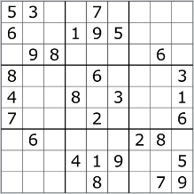

The following shows the code.

bool SolveSudoku(int a[][], int row, int col)
{
if (!GetNextEmptyCell(a, row, col))
{
return true;
}

for (int num = 1; num <= 9; num++)
{
if (checkRow(a, row, num) && checkCol(a, col, num) && checkBox(a, row, col, num))
{
a[row][col] = num;

if (SolveSudoku(a, row, col))
{
return true;
}

a[row][col] = 0;
}
}

return false;
}

bool GetNextEmptyCell(int a[][], int &row, int &col)
{
while (a[row][col] != 0)
{
if (col < 8)
++col;
else if (row < 8)
{
++row;
col = 0;
}
else
return false;
}

return true;
}

bool checkRow(int a[][], int row, int num)
{
for (int col = 0; col < 9; col++)
{
if (a[row][col] == num)
return false;
}
return true;
}

bool checkCol(int a[][], int col, int num)
{
for (int row = 0; row < 9; row++)
{
if (a[row][col] == num)
return false;
}
return true;
}

bool checkBox(int a[][], int row, int col, int num)
{
row = (row / 3) * 3;
col = (col / 3) * 3;

for (int i = 0; i < 3; i++)
{
for (int j = 0; j < 3; j++)
{
if (a[row + i][col + j] == num)
return false;
}
}
return true;
}

- Tower of Hanoi

The Tower of Hanoi problem consists of three towers and more than one rings with different sizes. Originally, these rings are placed around one tower in an ascending order.

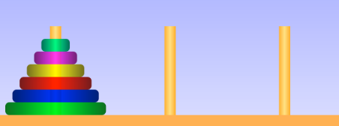

You need to move the rings to another towner with following the following rules:
- Only one disk can be moved at any time.
- No large ring can sit over a small ring.

The following shows how to use recursive to solve the problem.

void hanoi(int n, char a, char b, char c)
{
if (n == 1)
{
printf("Move disk 1 from %c to %c\n", a, b);
return;
}

hanoi(n - 1, a, c, b);
printf("Move disk %d from %c to %c\n", n, a, b);
hanoi(n - 1, c, b, a);
}

